**QBUS3350 – Topic 1 (Weeks 1-2)**

**Discussion Questions**

**1.1 Rank the determinants of project success from most important to least important and justify**

**your rankings.**

**1.2 Look at the first Chaos Report (available on CANVAS) produced by the Standish Group**

**back in 1994. What were the three major reasons for IT project success? How does this**

**compare to the three main reasons for project impairment or failure? How do the reasons align with your answers to Q1.1. Go to https://www.infoq.com/articles/standish-chaos-2015, which summarises the key findings of the 2015 Chaos Report. Have the reasons for IT project success changed much in 20 years?**

**1.3 As organisations seek to become better at managing projects, they often engage in**

**benchmarking with other companies in similar industries. Discuss the concept of benchmarking.**

**What are its goals? How does benchmarking work?**

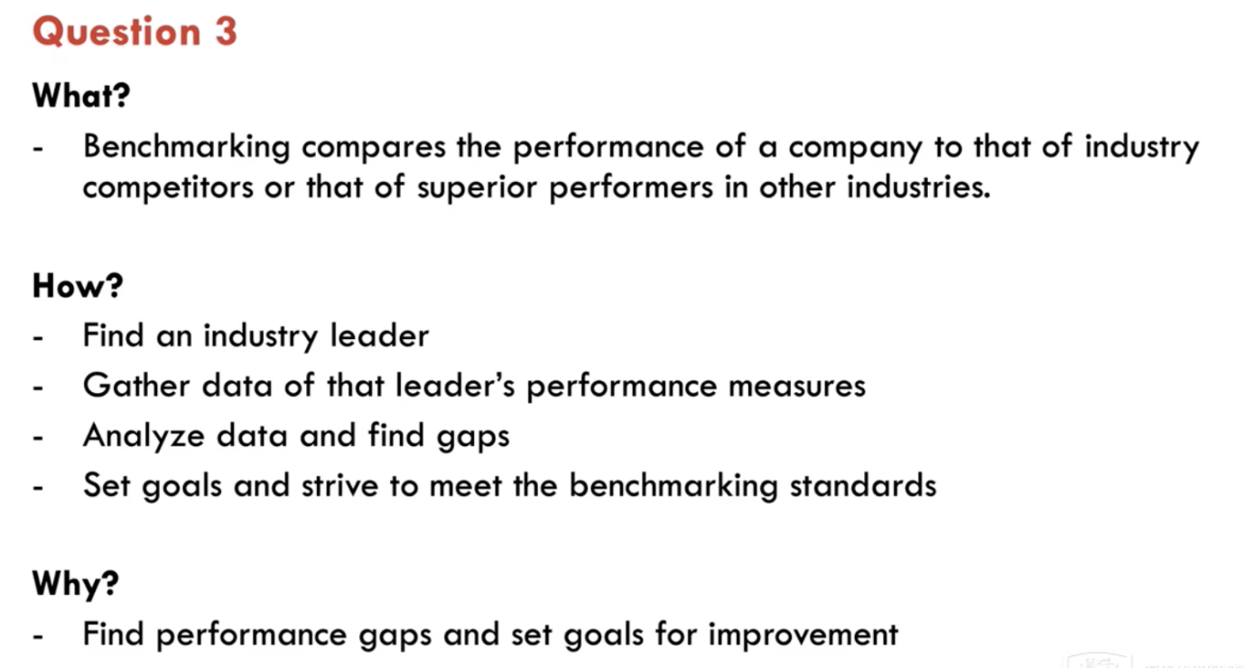

**1.4 What changes in the business environment have necessitated a greater use of project management skills? (Why project management is important?)**

1. Shortened product life cycles
2. Narrow product launch windows
3. Increasingly complex and technical products
4. Emergence of global markets
5. An economic period marked by low inflation

**1.5 Describe the features of a project. How do they differ from day-to-day processes within an organisation?**

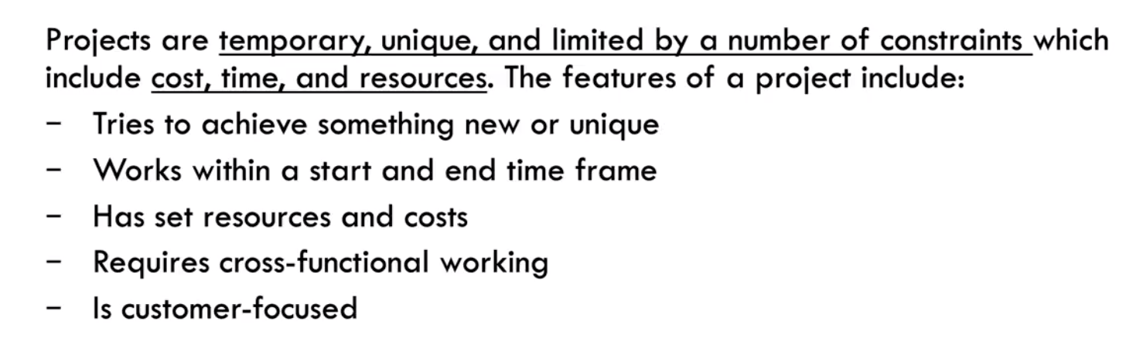

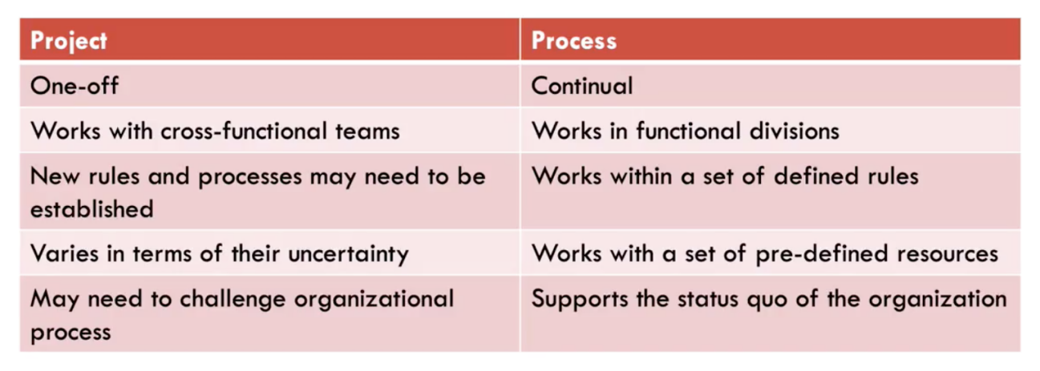

* ***Process*** is a continual thing, a ***project*** is a one-off. However, project managers should consider how the project will be sustained within the organization once it finishes.
* ***Processes*** tend to work in functional divisions of an organization (i.e. marketing, accounting), whereas ***projects*** usually consist of cross-functional teams.
* ***Processes*** work within a set of defined rules. For ***projects***, new rules and processes may need to be established.
* ***Processes*** work with a set of pre-defined resources. ***Projects*** can vary in terms of their uncertainty (may be prone to change), and therefore resource requirements may change through the lifecycle of the project.
* ***Processes*** support the status quo of the organization. ***Projects*** may need to challenge organizational processes if they do not meet the requirements of the project.

**1.6 Consider the case on the BBC Digital Initiative Media in this chapter: What do you see as**

**some of the main problems associated with the BBC’s approach to project management? What challenges did the project management team face in this project, and how can a firm responsible for large IT transformation projects overcome some of these challenges?**

**1.7 Read the NBN article dated 24 July, 2018 on Canvas. However, this article was published before the recent pandemic outbreak. Do your own research on the importance of the NBN project during the recent pandemic outbreak. Explain why the benefit of large-scale infrastructure projects such as NBN is difficult to evaluate. What is the relevant implication for project selection?**